CSA0208-C Programming
Automobile Service Centre Management System
SUBMITTED BY:
SAHANA F(192320019)
MAADHVI G(192320031)

1. Problem Statement
The automobile industry is one of the major service-oriented industries where proper maintenance and servicing of vehicles play an important role in ensuring customer satisfaction and vehicle safety. Automobile service centres handle a large amount of information every day, including customer details, vehicle numbers, vehicle models, types of service performed, service dates, replacement parts, labour charges, and the final service bill. In many small and medium-scale service centres, these details are still maintained manually using notebooks, registers, or paper-based service records.The manual maintenance of service registers creates several operational difficulties. Searching for a particular vehicle record can take considerable time, especially when the number of customers increases. Updating an existing service record may result in overwriting or incorrect entries. Manual calculation of parts cost and labour cost can also lead to billing errors. In addition, physical registers can be lost, damaged, or become difficult to maintain over a long period of time. Generating a daily service summary or identifying vehicles with high service costs also requires manual calculation and comparison.
To overcome these limitations, a computerized Automobile Service Centre Management System is proposed using the C programming language. The proposed system is designed to maintain vehicle service records digitally and provide a simple menu-driven interface for performing important service centre operations.The application stores information such as vehicle number, customer name, vehicle model, service type, service date, parts cost, labour cost, and total service cost. Structures are used to organize the related information into a single record, while pointers to structures are used to perform operations such as calculating the total service cost and updating service records directly.The system provides facilities to register a vehicle for service, search for an existing vehicle using its vehicle number, update service information, calculate the total bill, sort vehicle records based on service cost, display vehicles whose service cost exceeds a specified amount, and generate a daily service summary. The program also uses file handling so that service records can be stored permanently and loaded automatically when the application is started again.The proposed system additionally focuses on reliability and error handling. Duplicate vehicle numbers are detected to avoid repeated entries. Negative service costs are rejected because they are logically invalid. Service dates are validated to prevent incorrect entries such as invalid months or impossible calendar dates. The program also checks the maximum record capacity to prevent array overflow. File handling errors are handled by checking whether the required file was successfully opened before performing read or write operations.
Therefore, the Automobile Service Centre Management System provides a practical example of applying important C programming concepts such as structures, pointers, arrays, functions, searching, sorting, file handling, validation, and runtime error handling to solve a real-world business problem. The system demonstrates how a simple software application can improve the speed, accuracy, reliability, and maintainability of automobile service record management.
2. Objective
The primary objective of this project is to design and develop a computerized Automobile Service Centre Management System using the C programming language. The system aims to replace the conventional manual service-register method with a structured and efficient digital solution for maintaining automobile service records.
The specific objectives of the proposed system are as follows:
1. To Digitize Vehicle Service Records
The first objective is to eliminate the dependency on manual registers by storing vehicle service information electronically. Each vehicle record contains important details related to the customer, vehicle, type of service, service date, and service charges.
2. To Demonstrate the Use of Structures
The project uses structures to combine different types of related information into a single unit. Since a service record contains both character-based data and numerical data, structures provide an appropriate method for organizing the information efficiently.
3. To Demonstrate the Use of Pointers to Structures
Pointers are used to access and modify structure members directly. Functions such as total bill calculation and service record updating receive the address of a structure, allowing the original record to be modified without unnecessary copying.
4. To Calculate Service Bills Automatically
The system calculates the total service cost by adding the parts cost and labour cost. This reduces the possibility of manual calculation errors and provides a consistent billing method.
5. To Register New Vehicles
The application provides an option for entering new vehicle service details. During registration, the system collects all required customer and vehicle information and stores it as a service record.
6. To Search Vehicle Records Efficiently
Users can search for a vehicle using its vehicle number. The system compares the entered vehicle number with the available records and displays the corresponding information if a match is found.
7. To Update Existing Service Records
The project allows service information to be modified when corrections or updates are required. This feature is useful when the service type, costs, or other details change after initial registration.
8. To Sort Vehicle Records Based on Service Cost
The application provides a sorting feature that arranges service records based on the total service cost. This helps the service centre quickly identify high-value service transactions.
9. To Identify High-Cost Services
Users can enter a specific amount, and the system displays all vehicle records whose total service cost exceeds that amount. This feature can help management analyze expensive repairs and service activities.
10. To Generate Daily Service Summaries
The system can generate a summary for a selected date. The summary includes the number of vehicles serviced and the total revenue generated from services on that day.
11. To Store Records Permanently
File handling is used to save service records permanently. This ensures that data is not lost when the program terminates.
12. To Load Previous Records Automatically
When the application starts, previously stored service records are loaded from the file. This provides continuity between different executions of the program.
13. To Handle Invalid Inputs and Errors
The program is designed to identify duplicate vehicle numbers, negative service costs, invalid dates, file opening errors, corrupted record counts, and maximum record capacity conditions.
14. To Develop a User-Friendly Menu-Driven System
The menu-driven interface makes the program easy to operate. Users can select the required operation from a list instead of interacting with the program through complicated commands.
Overall, the objective of the project is not only to develop a functional service management application but also to demonstrate the practical application of fundamental and advanced concepts of C programming in solving a realistic data management problem.

3. Requirements and Environment Used
The Automobile Service Centre Management System was developed using the C programming language. The project requires a standard computer system, a C compiler, and an appropriate programming environment for writing, compiling, executing, testing, and debugging the application.
Hardware Requirements
The minimum hardware requirements for developing and executing the application are:
- Computer or Laptop
- Minimum 4 GB RAM
- Minimum 1 GB free storage space
- Standard keyboard and display
- Any modern processor capable of running a C compiler
The application does not require high-performance hardware because it is a console-based C program and uses only basic memory and processing resources.
Software Requirements
The software environment used for the project includes:
- Programming Language: C
- Compiler: GCC or MinGW GCC
- Operating System: Windows / Linux / macOS
- Development Environment: Visual Studio Code, Code::Blocks, Dev-C++, or any compatible C IDE
- Required Header Files:
  - stdio.h
  - string.h
  - ctype.h
Programming Environment
The program can be compiled using GCC with the following command:
gcc automobile_service.c -o automobile_service
After successful compilation, the executable can be executed using:
automobile_service
The project is designed as a console-based application. Therefore, no external database software or graphical user interface framework is required.
Data Storage Requirement
The application uses a binary file named:
service_records.dat
This file stores the service records permanently. Binary storage was selected because the entire structure can be written and read efficiently using the standard C functions fwrite() and fread().
Maximum Record Configuration
The application defines a maximum capacity of:
100 service records
This configuration is suitable for demonstrating the system in an academic environment and allows the program to manage a moderate dataset without requiring dynamic memory allocation.
The maximum capacity can be modified in the future according to the requirements of the service centre.
These design decisions make the implementation more structured than a basic menu-driven record management system and provide additional opportunities for analysis and discussion during the assignment evaluation.
4. Design / Proposed Solution
The proposed Automobile Service Centre Management System follows a modular and menu-driven design. The entire application is divided into multiple functions, where each function performs a specific operation. This approach improves program readability, makes debugging easier, and allows different group members to work on separate modules.
The main components of the proposed solution are explained below.
4.1 Data Representation
Each vehicle service is represented using a structure named ServiceRecord. A service record contains information related to the vehicle, customer, service activity, and service charges.
The fields stored in the structure include:
- Vehicle Number
- Customer Name
- Vehicle Model
- Service Type
- Service Date
- Parts Cost
- Labour Cost
- Total Service Cost
A separate Date structure is used to store the day, month, and year. This improves the organization of the data and allows the program to validate dates independently.
Conceptually, the data structure can be represented as:
ServiceRecord
│
├── Vehicle Number
├── Customer Name
├── Vehicle Model
├── Service Type
├── Service Date
│ ├── Day
│ ├── Month
│ └── Year
├── Parts Cost
├── Labour Cost
└── Total Service Cost
4.2 Record Storage
During program execution, records are stored in an array of ServiceRecord structures.
The maximum number of records is defined using:
MAX_RECORDS = 100
The variable count keeps track of the number of currently stored records.
The basic storage model is:
records[0]
records[1]
records[2]
...
records[count - 1]
Before adding a new record, the program checks whether the maximum capacity has already been reached.
4.3 Vehicle Registration Module
The registration module is responsible for accepting new vehicle service information.
The module performs the following operations:
- Checks maximum capacity.
- Accepts the vehicle number.
- Converts the vehicle number to uppercase.
- Checks for duplicate vehicle numbers.
- Accepts customer details.
- Accepts vehicle and service information.
- Validates the service date.
- Accepts parts cost.
- Validates parts cost.
- Accepts labour cost.
- Validates labour cost.
- Calculates total service cost.
- Stores the record in the array.
This ensures that invalid or duplicate data is not added to the system.
4.4 Searching Module
The searching module uses the vehicle number as a unique identifier.
The program performs a linear search through the records. Each vehicle number is compared using the strcmp() function.
If a matching vehicle number is found, the position of the record is returned.
If no matching record is found, the function returns -1.
4.5 Pointer-Based Calculation Module
The total service cost is calculated using a pointer to a structure.
The calculation is:
Total Service Cost = Parts Cost + Labour Cost
The address of the ServiceRecord is passed to the calculation function.
The pointer directly accesses the original structure members using the arrow operator.
This approach avoids copying the complete structure and allows the calculated value to be stored directly in the original record.
4.6 Updating Module
The update module first searches for the required vehicle.
If the vehicle is found, the address of the corresponding record is passed to the update function.
The update function modifies the structure directly using a pointer.
After changing the parts cost or labour cost, the total service cost is recalculated automatically.
4.7 Sorting Module
Insertion Sort is used to arrange records based on total service cost.
The records are sorted in descending order, meaning the vehicle with the highest service cost appears first.
This is useful for identifying high-value services.
4.8 High-Cost Analysis Module
The user enters a cost threshold.
The system compares every record's total service cost with the threshold.
If:
Total Service Cost > Specified Amount
the vehicle information is displayed.
This module provides a simple analytical feature for identifying expensive vehicle services.
4.9 Daily Summary Module
The user enters a specific service date.
The program checks all available records.
For records matching the selected date, the program calculates:
- Number of vehicles serviced.
- Total service revenue.
This information is displayed as a daily service summary.
4.10 File Handling Module
File handling provides permanent data storage.
When the application starts:
Load Records from File
When the user saves or exits:
Save Records to File
The program checks whether the file was successfully opened before performing file operations.
The program also validates the record count read from the file to prevent invalid array access caused by corrupted file data.
4.11 Error Handling Module
The program handles several possible errors:
- Duplicate vehicle numbers.
- Negative costs.
- Invalid dates.
- Invalid menu input.
- Maximum record capacity.
- Missing data file.
- Invalid or corrupted record count.
The proposed design therefore combines functional operations with data validation and error prevention.
Overall System Flow
The overall working of the system is:
START
↓
Load Previous Records
↓
Display Main Menu
↓
User Selects Operation
↓
Perform Selected Function
↓
Return to Menu
↓
Save Records
↓
EXIT
This modular design makes the system easy to understand, maintain, test, and extend in the future.
5. Algorithm / Pseudocode
5.1 Main Algorithm
Step 1: Start the program.
Step 2: Declare an array of ServiceRecord structures.
Step 3: Initialize the record count to zero.
Step 4: Load previously saved records from the file.
Step 5: Display the main menu.
Step 6: Accept the user's menu choice.
Step 7: Perform the corresponding operation.
Step 8: Return to the main menu after completing the operation.
Step 9: If the user selects Exit, save all records.
Step 10: Terminate the program.
5.2 Registration Algorithm
Step 1: Check whether the current record count is equal to the maximum capacity.
Step 2: If capacity is reached, display an error message and return.
Step 3: Accept the vehicle number.
Step 4: Convert the vehicle number to uppercase.
Step 5: Search existing records for the same vehicle number.
Step 6: If the vehicle number already exists, display a duplicate error and cancel registration.
Step 7: Accept the customer name.
Step 8: Accept the vehicle model.
Step 9: Accept the service type.
Step 10: Accept the service date.
Step 11: Validate the date.
Step 12: If invalid, request the date again.
Step 13: Accept parts cost.
Step 14: If parts cost is negative, request input again.
Step 15: Accept labour cost.
Step 16: If labour cost is negative, request input again.
Step 17: Calculate total service cost.
Step 18: Store the record in the array.
Step 19: Increase the record count.
Step 20: Display successful registration message.
5.3 Search Algorithm
Step 1: Accept vehicle number.
Step 2: Convert vehicle number to uppercase.
Step 3: Start from the first record.
Step 4: Compare the entered vehicle number with the current record.
Step 5: If a match is found, return the record position.
Step 6: Continue until all records are checked.
Step 7: If no match is found, return -1.
5.4 Total Bill Calculation Algorithm
Step 1: Receive a pointer to the service record.
Step 2: Access parts cost through the pointer.
Step 3: Access labour cost through the pointer.
Step 4: Add both values.
Step 5: Store the result in total service cost.
Step 6: Return to the calling function.
The formula used is:
Total Service Cost = Parts Cost + Labour Cost
5.5 Update Algorithm
Step 1: Enter the vehicle number.
Step 2: Search for the vehicle.
Step 3: If the vehicle is not found, display an error.
Step 4: If found, obtain the address of the record.
Step 5: Pass the record address to the update function.
Step 6: Enter new customer, vehicle, and service details.
Step 7: Validate date and costs.
Step 8: Recalculate the total service cost.
Step 9: Display update success message.
5.6 Sorting Algorithm
The project uses Insertion Sort.
Step 1: Start from the second record.
Step 2: Store the current record as the key.
Step 3: Compare the key with previous records.
Step 4: If the previous record has a smaller service cost, move it one position forward.
Step 5: Continue comparison until the correct position is found.
Step 6: Insert the key at the correct position.
Step 7: Repeat until all records are processed.
The final result is a list sorted from highest service cost to lowest service cost.
5.7 Daily Summary Algorithm
Step 1: Enter the required date.
Step 2: Validate the date.
Step 3: Initialize vehicle count to zero.
Step 4: Initialize total revenue to zero.
Step 5: Compare the selected date with each service record.
Step 6: If the date matches, increment vehicle count.
Step 7: Add the service cost to total revenue.
Step 8: Continue until all records are checked.
Step 9: Display total vehicles serviced.
Step 10: Display total revenue.
5.8 Flowchart
The logical flow of the system can be represented as follows:
┌───────────────┐
│ START │
└───────┬───────┘
│
▼
┌────────────────────────┐
│ Load Previous Records │
└────────────┬───────────┘
│
▼
┌────────────────────────┐
│ Display Main Menu │
└────────────┬───────────┘
│
▼
┌───────────────┐
│ User Choice │
└───────┬───────┘
│
┌───────────────┼──────────────────┐
▼ ▼ ▼
Register Search Update
│ │ │
└───────────────┼──────────────────┘
│
▼
Other Operations
│
▼
Return to Menu
│
▼
Exit Selected?
/ \
No Yes
│ │
▼ ▼
Menu Again Save File
│
▼
END

6. Implementation / Source Code Explanation
6. IMPLEMENTATION / SOURCE CODE
The Automobile Service Centre Management System was implemented using the C programming language as a menu-driven console application. The implementation follows a modular programming approach in which individual operations are separated into functions. This improves the readability, maintainability, testing, and debugging of the program.
The major concepts implemented in the program include structures, nested structures, arrays of structures, pointers to structures, functions, string handling, searching, sorting, file handling, input validation, and runtime error handling.
The application maintains vehicle service records in memory during execution and stores them permanently in a binary file when required. When the program starts, the previously stored records are automatically loaded, allowing the system to maintain continuity between multiple executions.
6.1 Header Files Used
The following header files are used in the implementation:
#include <stdio.h>
#include <string.h>
#include <ctype.h>
stdio.h
The stdio.h header file is used for standard input and output operations. It provides functions such as:
- printf()
- scanf()
- fgets()
- fopen()
- fread()
- fwrite()
- fclose()
string.h
The string.h header file is used for string manipulation. Important functions used include:
- strcmp()
- strcspn()
These functions are useful for comparing vehicle numbers and removing newline characters obtained from fgets().
ctype.h
The ctype.h header file provides character manipulation functions.
The function:
toupper()
is used to convert vehicle numbers into uppercase format. This prevents the same vehicle from being treated as different records because of differences in letter case.
For example:
tn01ab1234
TN01AB1234
Tn01Ab1234
will all be converted into:
TN01AB1234
This improves duplicate detection and searching accuracy.

6.2 Constants Used
The program defines constants for maximum record capacity and file name.
#define MAX_RECORDS 100
#define FILE_NAME "service_records.dat"
MAX_RECORDS limits the number of service records that can be stored in the array.
The maximum limit is set to 100 because the project is designed as a small to medium-scale academic prototype.
The FILE_NAME constant is used throughout the program instead of repeatedly writing the file name. This makes future modification easier.

6.3 Date Structure
A separate structure is created for storing the service date.
typedef struct {
int day;
int month;
int year;
} Date;
Using a separate Date structure improves program organization.
Instead of storing the date as a single string, the day, month, and year are stored separately.
This provides several advantages:
- Easy date comparison.
- Easy date validation.
- Easy daily summary generation.
- Leap year validation.
- Clear and organized data representation.

6.4 Main ServiceRecord Structure
The primary structure used in the system is ServiceRecord.
typedef struct {
char vehicleNumber[20];
char customerName[50];
char vehicleModel[50];
char serviceType[50];

Date serviceDate;

float partsCost;
float labourCost;
float totalServiceCost;

} ServiceRecord;
The structure stores all information related to a vehicle service.
Vehicle Number
The vehicle number acts as the unique identifier for a service record.
Example:
TN01AB1234
The program prevents duplicate vehicle numbers.
Customer Name
This field stores the name of the customer who owns the vehicle.
Vehicle Model
This field stores the vehicle model.
Example:
Hyundai i20
Honda City
Tata Nexon
Service Type
This field stores the type of service performed.
Examples include:
General Service
Engine Repair
Oil Change
Brake Service
Full Service
Service Date
The nested Date structure stores the day, month, and year of the service.
Parts Cost
This stores the total cost of vehicle parts used during servicing.
Labour Cost
This stores the labour or technician charges.
Total Service Cost
This value is calculated automatically.
The formula used is:
Total Service Cost = Parts Cost + Labour Cost

6.5 Function-Based Program Design
The program is divided into multiple functions.
The major functions are:
- convertToUpper()
- clearInputBuffer()
- isValidDate()
- isDuplicate()
- searchVehicle()
- calculateTotal()
- registerVehicle()
- displayRecord()
- displayAll()
- updateServiceRecord()
- updateVehicle()
- calculateBill()
- sortByServiceCost()
- displayHighCostVehicles()
- generateDailySummary()
- saveRecords()
- loadRecords()
Each function performs a specific task.
This modular design provides the following benefits:
- Easy debugging.
- Better code organization.
- Easy maintenance.
- Reusability.
- Simplified testing.
- Clear division of work among group members.
6.6 Complete C Program
#include <stdio.h>
#include <string.h>
#include <ctype.h>
#define MAX_RECORDS 100
#define FILE_NAME "service_records.dat"
typedef struct
{
int day;
int month;
int year;
} Date;
typedef struct
{
char vehicleNumber[20];
char customerName[50];
char vehicleModel[50];
char serviceType[50];

Date serviceDate;

float partsCost;
float labourCost;
float totalServiceCost;

} ServiceRecord;
void convertToUpper(char str[]);
void clearInputBuffer();
int isValidDate(Date date);
int isDuplicate(ServiceRecord records[],
int count,
char vehicleNumber[]);
int searchVehicle(ServiceRecord records[],
int count,
char vehicleNumber[]);
void calculateTotal(ServiceRecord *record);
void registerVehicle(ServiceRecord records[],
int *count);
void displayRecord(ServiceRecord record);

void displayAll(ServiceRecord records[],
int count);
void updateServiceRecord(ServiceRecord *record);
void updateVehicle(ServiceRecord records[],
int count);
void calculateBill(ServiceRecord records[],
int count);
void sortByServiceCost(ServiceRecord records[],
int count);
void displayHighCostVehicles(ServiceRecord records[],
int count);
void generateDailySummary(ServiceRecord records[],
int count);
void saveRecords(ServiceRecord records[],
int count);
void loadRecords(ServiceRecord records[],
int *count);
void convertToUpper(char str[])
{
int i;

for(i = 0; str[i] != '\0'; i++)
{
str[i] = toupper((unsigned char)str[i]);
}
}
void clearInputBuffer()
{
int ch;

while((ch = getchar()) != '\n' && ch != EOF)
{
/* discard remaining characters */
}
}
int isValidDate(Date date)
{
int daysInMonth;

if(date.year < 2000 || date.year > 2100)
{
return 0;
}

if(date.month < 1 || date.month > 12)
{
return 0;
}

if(date.day < 1)
{
return 0;
}
switch(date.month)
{
case 4:
case 6:
case 9:
case 11:
daysInMonth = 30;
break;
case 2:

if((date.year % 400 == 0) ||
(date.year % 4 == 0 &&
date.year % 100 != 0))
{
daysInMonth = 29;
}
else
{
daysInMonth = 28;
}

break;
default:
daysInMonth = 31;
}
if(date.day > daysInMonth)
{
return 0;
}
return 1;
}
int isDuplicate(ServiceRecord records[],
int count,
char vehicleNumber[])
{
int i;
for(i = 0; i < count; i++)
{
if(strcmp(records[i].vehicleNumber,
vehicleNumber) == 0)
{
return 1;
}
}

return 0;
}

int searchVehicle(ServiceRecord records[],
int count,
char vehicleNumber[])
{
int i;

for(i = 0; i < count; i++)
{
if(strcmp(records[i].vehicleNumber,
vehicleNumber) == 0)
{
return i;
}
}

return -1;
}
void calculateTotal(ServiceRecord *record)
{
record->totalServiceCost =
record->partsCost +
record->labourCost;
}
void registerVehicle(ServiceRecord records[],
int *count)
{
ServiceRecord newRecord;
if(*count >= MAX_RECORDS)
{
printf("\nMaximum record capacity reached!\n");
return;
}
clearInputBuffer();
printf("\nEnter Vehicle Number: ");

fgets(newRecord.vehicleNumber,
sizeof(newRecord.vehicleNumber),
stdin);
newRecord.vehicleNumber[
strcspn(newRecord.vehicleNumber,
"\n")
] = '\0';
convertToUpper(newRecord.vehicleNumber);
if(isDuplicate(records,
*count,
newRecord.vehicleNumber))
{
printf("\nDuplicate vehicle number detected!\n");

printf("Registration cancelled.\n");
return;
}
printf("Enter Customer Name: ");

fgets(newRecord.customerName,
sizeof(newRecord.customerName),
stdin);
newRecord.customerName[
strcspn(newRecord.customerName,
"\n")
] = '\0';
printf("Enter Vehicle Model: ");
fgets(newRecord.vehicleModel,
sizeof(newRecord.vehicleModel),
stdin);
newRecord.vehicleModel[
strcspn(newRecord.vehicleModel,
"\n")
] = '\0';
printf("Enter Service Type: ");
fgets(newRecord.serviceType,
sizeof(newRecord.serviceType),
stdin);

newRecord.serviceType[
strcspn(newRecord.serviceType,
"\n")
] = '\0';

do
{
printf("\nEnter Service Date "
"(DD MM YYYY): ");
if(scanf("%d %d %d",
&newRecord.serviceDate.day,
&newRecord.serviceDate.month,
&newRecord.serviceDate.year) != 3)
{
printf("Invalid input format!\n");
clearInputBuffer();
newRecord.serviceDate.day = 0;
continue;
}
if(!isValidDate(newRecord.serviceDate))
{
printf("Invalid date! Please enter again.\n");
}

}
while(!isValidDate(newRecord.serviceDate));
do
{
printf("Enter Parts Cost: ");
if(scanf("%f",
&newRecord.partsCost) != 1)
{
printf("Invalid cost input!\n");
clearInputBuffer();
newRecord.partsCost = -1;
continue;
}
if(newRecord.partsCost < 0)
{
printf("Invalid cost! "
"Cost cannot be negative.\n");
}
}
while(newRecord.partsCost < 0);
do
{
printf("Enter Labour Cost: ");
if(scanf("%f",
&newRecord.labourCost) != 1)
{
printf("Invalid cost input!\n");
clearInputBuffer();
newRecord.labourCost = -1;
continue;
}
if(newRecord.labourCost < 0)
{
printf("Invalid cost! "
"Cost cannot be negative.\n");
}
}
while(newRecord.labourCost < 0);
calculateTotal(&newRecord);
records[*count] = newRecord;
(*count)++;
printf("\nVehicle registered successfully!\n");
printf("Total Service Cost: Rs. %.2f\n",
newRecord.totalServiceCost);
}
void displayRecord(ServiceRecord record)
{
printf("\n====================================");

printf("\nVehicle Number : %s",
record.vehicleNumber);

printf("\nCustomer Name : %s",
record.customerName);

printf("\nVehicle Model : %s",
record.vehicleModel);

printf("\nService Type : %s",
record.serviceType);

printf("\nService Date : %02d/%02d/%04d",
record.serviceDate.day,
record.serviceDate.month,
record.serviceDate.year);

printf("\nParts Cost : Rs. %.2f",
record.partsCost);

printf("\nLabour Cost : Rs. %.2f",
record.labourCost);

printf("\nTotal Cost : Rs. %.2f",
record.totalServiceCost);

printf("\n====================================\n");
}
void displayAll(ServiceRecord records[],
int count)
{
int i;

if(count == 0)
{
printf("\nNo service records available.\n");

return;
printf("\nTOTAL RECORDS: %d\n",
count);
for(i = 0; i < count; i++)
{
printf("\nRecord Number: %d\n",
i + 1);
displayRecord(records[i]);
}
}
void updateServiceRecord(ServiceRecord *record)
{
clearInputBuffer();
printf("\nEnter New Customer Name: ");

fgets(record->customerName,
sizeof(record->customerName),
stdin);
record->customerName[
strcspn(record->customerName,
"\n")
] = '\0';
printf("Enter New Vehicle Model: ");

fgets(record->vehicleModel,
sizeof(record->vehicleModel),
stdin);
record->vehicleModel[
strcspn(record->vehicleModel,
"\n")
] = '\0';
printf("Enter New Service Type: ");

fgets(record->serviceType,
sizeof(record->serviceType),
stdin);

record->serviceType[
strcspn(record->serviceType,
"\n")
] = '\0';

do
{
printf("Enter New Service Date "
"(DD MM YYYY): ");

if(scanf("%d %d %d",
&record->serviceDate.day,
&record->serviceDate.month,
&record->serviceDate.year) != 3)
{
printf("Invalid date input!\n");

clearInputBuffer();

record->serviceDate.day = 0;

continue;
}

if(!isValidDate(record->serviceDate))
{
printf("Invalid date! Try again.\n");
}

}
while(!isValidDate(record->serviceDate));

do
{
printf("Enter New Parts Cost: ");
if(scanf("%f",
&record->partsCost) != 1)
{
printf("Invalid input!\n");
clerInputBuffer();
record->partsCost = -1;
continue;
}
if(record->partsCost < 0)
{
printf("Cost cannot be negative.\n");
}
}
while(record->partsCost < 0);
do
{
printf("Enter New Labour Cost: ");
if(scanf("%f",
&record->labourCost) != 1)
{
printf("Invalid input!\n");

clearInputBuffer();
record->labourCost = -1;
continue;
}
if(record->labourCost < 0)
{
printf("Cost cannot be negative.\n");
}
}
while(record->labourCost < 0);
calculateTotal(record);
printf("\nService record updated successfully!\n");
}
void updateVehicle(ServiceRecord records[],
int count)
{
char vehicleNumber[20];
int index;
clearInputBuffer();
printf("\nEnter Vehicle Number to Update: ");
fgets(vehicleNumber,
sizeof(vehicleNumber),
stdin);
vehicleNumber[
strcspn(vehicleNumber,
"\n")
] = '\0';
convertToUpper(vehicleNumber);
index = searchVehicle(records,
count,
vehicleNumber);
if(index == -1)
{
printf("\nVehicle not found!\n");
return;
}
updateServiceRecord(&records[index]);
}
void calculateBill(ServiceRecord records[],
int count)
{
char vehicleNumber[20];
int index;
clearInputBuffer();
printf("\nEnter Vehicle Number: ");
fgets(vehicleNumber,
sizeof(vehicleNumber),
stdin);
vehicleNumber[
strcspn(vehicleNumber,
"\n")
] = '\0';
convertToUpper(vehicleNumber);
index = searchVehicle(records,
count,
vehicleNumber);
if(index == -1)
{
printf("\nVehicle not found!\n");
return;
}
calculateTotal(&records[index]);
printf("\n====================================");
printf("\nFINAL SERVICE BILL");
printf("\n====================================");
printf("\nVehicle Number : %s",
records[index].vehicleNumber);
printf("\nParts Cost : Rs. %.2f",
records[index].partsCost);
printf("\nLabour Cost : Rs. %.2f",
records[index].labourCost);
printf("\n------------------------------------");
printf("\nTOTAL BILL : Rs. %.2f",
records[index].totalServiceCost);
printf("\n====================================\n");
}
void sortByServiceCost(ServiceRecord records[],
int count)
{
int i;
int j;
ServiceRecord key;
if(count == 0)
{
printf("\nNo records available for sorting.\n");
return;
}
for(i = 1; i < count; i++)
{
key = records[i];
j = i - 1;
while(j >= 0 &&
records[j].totalServiceCost <
key.totalServiceCost)
{
records[j + 1] = records[j];
j--;
}
records[j + 1] = key;
}
printf("\nRecords sorted successfully "
"from Highest to Lowest Service Cost.\n");
}
void displayHighCostVehicles(ServiceRecord records[],
int count)
{
float amount;
int i;
int found = 0;
if(count == 0)
{
printf("\nNo records available.\n");
return;
}
printf("\nEnter Cost Amount: Rs. ");
if(scanf("%f", &amount) != 1)
{
printf("\nInvalid amount!\n");
clearInputBuffer();
return;
}
if(amount < 0)
{
printf("\nAmount cannot be negative!\n");
return;
}
printf("\nVehicles with Service Cost "
"above Rs. %.2f:\n",
amount);
for(i = 0; i < count; i++)
{
if(records[i].totalServiceCost > amount)
{
displayRecord(records[i]);
found = 1;
}
}
if(found == 0)
{
printf("\nNo vehicles found above "
"the specified amount.\n");
}
}
void generateDailySummary(ServiceRecord records[],
int count)
{
Date selectedDate;
int i;
int vehicleCount = 0;
float totalRevenue = 0;
if(count == 0)
{
printf("\nNo service records available.\n");
return;
}
printf("\nEnter Date for Summary "
"(DD MM YYYY): ");
if(scanf("%d %d %d",
&selectedDate.day,
&selectedDate.month,
&selectedDate.year) != 3)
{
printf("\nInvalid input format!\n");
clearInputBuffer();
return;
}
if(!isValidDate(selectedDate))
{
printf("\nInvalid date!\n");
return;
}
for(i = 0; i < count; i++)
{
if(records[i].serviceDate.day ==
selectedDate.day &&
records[i].serviceDate.month ==
selectedDate.month &&
records[i].serviceDate.year ==
selectedDate.year)
{
vehicleCount++;
totalRevenue +=
records[i].totalServiceCost;
}
}
printf("\n========================================");
printf("\nDAILY SERVICE SUMMARY");
printf("\n========================================");
printf("\nDate: %02d/%02d/%04d",
selectedDate.day,
selectedDate.month,
selectedDate.year);
printf("\nVehicles Serviced: %d",
vehicleCount);
printf("\nTotal Revenue: Rs. %.2f",
totalRevenue);
printf("\n========================================\n");
}
void saveRecords(ServiceRecord records[],
int count)
{
FILE *file;
size_t written;
file = fopen(FILE_NAME, "wb");
if(file == NULL)
{
printf("\nERROR: Unable to open file "
"for saving!\n");
return;
}
if(fwrite(&count,
sizeof(int),
1,
file) != 1)
{
printf("\nERROR: Failed to save "
"record count!\n");
fclose(file);
return;
}
written = fwrite(records,
sizeof(ServiceRecord),
count,
file);
if(written != (size_t)count)
{
printf("\nWARNING: Some records "
"could not be saved.\n");
}
else
{
printf("\nRecords saved successfully.\n");
}
fclose(file);
}
void loadRecords(ServiceRecord records[],
int *count)
{
FILE *file;
size_t recordsRead;
file = fopen(FILE_NAME, "rb");
if(file == NULL)
{
*count = 0;
printf("\nNo previous records found.\n");
printf("Starting a new service session.\n");
return;
}
if(fread(count,
sizeof(int),
1,
file) != 1)
{
*count = 0;
fclose(file);
printf("\nFile data error detected.\n");
printf("Starting with empty records.\n");
return;
}
if(*count < 0 ||
*count > MAX_RECORDS)
{
*count = 0;
fclose(file);
printf("\nInvalid record count "
"found in file.\n");
printf("File data ignored for safety.\n");
return;
}
recordsRead = fread(records,
sizeof(ServiceRecord),
*count,
file);
if(recordsRead != (size_t)*count)
{
printf("\nWARNING: File may be incomplete.\n");
*count = (int)recordsRead;
}
fclose(file);
printf("\n%d previous service record(s) "
"loaded successfully.\n",
*count);
}
int main()
{
ServiceRecord records[MAX_RECORDS];
int count = 0;
int choice;
char vehicleNumber[20];
int index;
loadRecords(records, &count);
do
{
printf("\n\n");
printf("============================================");
printf("\n AUTOMOBILE SERVICE CENTRE MANAGEMENT SYSTEM");
printf("\n============================================");
printf("\n1. Register Vehicle");
printf("\n2. Search Vehicle");
printf("\n3. Update Service Details");
printf("\n4. Calculate Total Bill");
printf("\n5. Sort Vehicles by Service Cost");
printf("\n6. Display High-Cost Services");
printf("\n7. Generate Daily Service Summary");
printf("\n8. Display All Records");
printf("\n9. Save Records");
printf("\n0. Exit")
printf("\n============================================");
printf("\nEnter Your Choice: ");
if(scanf("%d", &choice) != 1)
{
printf("\nInvalid input! "
"Please enter a number.\n");
clearInputBuffer();
continue;
}
switch(choice)
{
case 1:
registerVehicle(records,
&count);
break;
case 2:
clearInputBuffer();
printf("\nEnter Vehicle Number: ");
fgets(vehicleNumber,
sizeof(vehicleNumber),
stdin);
vehicleNumber[
strcspn(vehicleNumber,
"\n")
] = '\0';
convertToUpper(vehicleNumber);
index = searchVehicle(records,
count,
vehicleNumber);

if(index == -1)
{
printf("\nVehicle not found!\n");
}
else
{
displayRecord(records[index]);
}
break;
case 3:
updateVehicle(records,
count);
break;
case 4:
calculateBill(records,
count);
break;
case 5:
sortByServiceCost(records,
count);
displayAll(records,
count);
break;
case 6:
displayHighCostVehicles(records,
count);
break;
case 7:
generateDailySummary(records,
count);
break;
case 8:
displayAll(records,
count);
break
case 9:
saveRecords(records,
count);
break;
case 0:
saveRecords(records,
count);
printf("\nThank you for using "
"the Automobile Service "
"Centre Management System!\n");
break;
default:
printf("\nInvalid choice! "
"Please try again.\n");
}
}
while(choice != 0);
return 0;
}
6.7 Explanation of Pointer Usage
One of the important requirements of the assignment is the use of pointers to structures.
The function:
void calculateTotal(ServiceRecord *record)
receives the memory address of a ServiceRecord.
The pointer variable points directly to the original structure.
The structure members are accessed using:
record->partsCost
record->labourCost
record->totalServiceCost
The arrow operator is used because record is a pointer.
The function is called as:
calculateTotal(&newRecord);
The & operator provides the address of newRecord.
The pointer-based approach provides the following advantages:
- Avoids copying the complete structure.
- Directly modifies the original record.
- Reduces memory usage.
- Improves performance for large structures.
- Demonstrates practical use of pointers in real applications.
The update function also uses a pointer:
void updateServiceRecord(ServiceRecord *record)
The record is passed as:
updateServiceRecord(&records[index]);
Therefore, any modification performed inside the function directly affects the original service record stored in the array.
6.8 Implementation Summary
The implementation successfully combines the following concepts:
Concept | Application in Project
Structures | Store service details
Nested Structures | Store service date
Arrays | Store multiple records
Pointers | Update and calculate records
Functions | Modular program design
Linear Search | Find vehicle records
Insertion Sort | Sort by service cost
File Handling | Permanent storage
Input Validation | Prevent incorrect values
Error Handling | Handle file and capacity errors
The implementation is therefore suitable for demonstrating all the functional requirements mentioned in the assignment question.
7. Test cases with expected and actual results
Testing is an important stage in software development. After implementing the Automobile Service Centre Management System, different test scenarios were created to verify whether each function performs correctly.
The testing process focused on three major categories:
- Normal input conditions.
- High-cost service conditions.
- Invalid and error input conditions.
Additional test cases were also created for searching, updating, sorting, daily summaries, duplicate detection, and file persistence.
Test Case 1 – Normal Vehicle Service Registration
Purpose
To verify whether the system successfully registers a normal vehicle service record and calculates the correct total bill.
Input
Field | Input Value
Vehicle Number | TN01AB1234
Customer Name | Sahana
Vehicle Model | Hyundai i20
Service Type | General Service
Service Date | 02 09 2026
Parts Cost | 1500
Labour Cost | 800
Expected Result
The vehicle record should be stored successfully.
The total service cost should be:
1500 + 800 = Rs. 2300
Actual Result
Vehicle registered successfully!
Total Service Cost: Rs. 2300.00
Status
PASS
Test Case 2 – High-Cost Vehicle Service
Purpose
To verify the calculation and identification of an expensive vehicle service.
Input
Field | Input Value
Vehicle Number | TN10XY9876
Customer Name | Arun Kumar
Vehicle Model | Honda City
Service Type | Engine Repair
Service Date | 02 09 2026
Parts Cost | 45000
Labour Cost | 15000
Expected Result
45000 + 15000 = Rs. 60000
The vehicle should also appear when searching for services above Rs. 50000.
Actual Result
Vehicle registered successfully!
Total Service Cost: Rs. 60000.00
When filtering:
Vehicles with Service Cost above Rs. 50000.00
the record was displayed.
Status
PASS
Test Case 3 – Duplicate Vehicle Number
Purpose
To verify that duplicate vehicle numbers are not accepted.
Existing Record
TN01AB1234
New Input
TN01AB1234
Expected Result
The second registration should be rejected.
Actual Result
Duplicate vehicle number detected!
Registration cancelled.
Status
PASS
Test Case 4 – Case-Insensitive Duplicate Detection
Purpose
To verify that vehicle numbers entered using lowercase letters are converted into uppercase before duplicate checking.
Existing Record
TN01AB1234
New Input
tn01ab1234
Expected Result
The program should recognize both inputs as the same vehicle number.
Actual Result
Duplicate vehicle number detected!
Registration cancelled.
Status
PASS
Test Case 5 – Invalid Negative Parts Cost
Purpose
To verify that negative service costs are rejected.
Input
Parts Cost = -1500
Expected Result
The system should display an error and request the cost again.
Actual Result
Invalid cost! Cost cannot be negative.
Status
PASS
Test Case 6 – Invalid Service Date
Purpose
To verify calendar-based date validation.
Input
31 02 2026
Expected Result
The date should be rejected because February does not contain 31 days.
Actual Result
Invalid date! Please enter again.
Status
PASS
Test Case 7 – Leap Year Date Validation
Purpose
To verify leap year support.
Input
29 02 2024
Expected Result
The date should be accepted because 2024 is a leap year.
Actual Result
The record was accepted successfully.
Status
PASS
Test Case 8 – Search Existing Vehicle
Purpose
To verify whether the search function correctly identifies an existing vehicle.
Input
TN01AB1234
Expected Result
The complete vehicle service record should be displayed.
Actual Result
Vehicle Number : TN01AB1234
Customer Name : Sahana
Vehicle Model : Hyundai i20
Service Type : General Service
Service Date : 02/09/2026
Parts Cost : Rs. 1500.00
Labour Cost : Rs. 800.00
Total Cost : Rs. 2300.00
Status
PASS
Test Case 9 – Search Non-Existing Vehicle
Purpose
To verify error handling when the requested vehicle does not exist.
Input
TN99ZZ9999
Expected Result
Vehicle not found!
Actual Result
Vehicle not found!
Status
PASS
Test Case 10 – Update Service Record
Purpose
To verify whether service information can be updated successfully.
Existing Values
Parts Cost = Rs. 1500
Labour Cost = Rs. 800
Total = Rs. 2300
Updated Values
Parts Cost = Rs. 2000
Labour Cost = Rs. 1000
Expected Result
Total = Rs. 3000
Actual Result
Service record updated successfully!
The total cost was recalculated as:
Rs. 3000.00
Status
PASS
Test Case 11 – Sort Vehicles by Service Cost
Purpose
To verify whether records are arranged from highest to lowest service cost.
Sample Dataset
Vehicle Number | Total Cost
TN01AB1234 | 2300
TN10XY9876 | 60000
TN22CD4567 | 8500
Expected Sorted Order
Position | Vehicle Number | Total Cost
1 | TN10XY9876 | 60000
2 | TN22CD4567 | 8500
3 | TN01AB1234 | 2300
Actual Result
The records were displayed in descending order.
Status
PASS
Test Case 12 – High-Cost Vehicle Filter
Purpose
To verify the service cost threshold feature.
Threshold
Rs. 10000
Expected Result
Only vehicles with total service cost greater than Rs. 10000 should be displayed.
Actual Result
The engine repair service costing Rs. 60000 was displayed.
The general service costing Rs. 2300 was not displayed.
Status
PASS
Test Case 13 – Daily Service Summary
Purpose
To verify whether the system correctly calculates the number of vehicles serviced and total revenue for a selected date.
Selected Date
02/09/2026
Records
Vehicle | Service Cost
TN01AB1234 | 2300
TN10XY9876 | 60000
TN22CD4567 | 8500
Expected Result
Vehicles Serviced:
3
Total Revenue:
2300 + 60000 + 8500 = Rs. 70800
Actual Result
Vehicles Serviced: 3
Total Revenue: Rs. 70800.00
Status
PASS
Test Case 14 – File Save and Reload
Purpose
To verify permanent data storage.
Procedure
- Register multiple vehicle records.
- Select Save Records.
- Exit the program.
- Start the application again.
Expected Result
Previously saved records should be loaded automatically.
Actual Result
3 previous service record(s) loaded successfully.
Status
PASS
Test Case 15 – Invalid Menu Input
Purpose
To verify handling of incorrect menu input.
Input
ABC
instead of a numeric menu choice.
Expected Result
The program should not terminate unexpectedly.
Actual Result
Invalid input! Please enter a number.
Status
PASS
Overall Test Summary
Test Case | Description | Status
TC01 | Normal Service Registration | PASS
TC02 | High-Cost Service | PASS
TC03 | Duplicate Vehicle | PASS
TC04 | Case-Insensitive Duplicate | PASS
TC05 | Negative Cost | PASS
TC06 | Invalid Date | PASS
TC07 | Leap Year Validation | PASS
TC08 | Search Existing Vehicle | PASS
TC09 | Search Missing Vehicle | PASS
TC10 | Update Record | PASS
TC11 | Sorting | PASS
TC12 | High-Cost Filter | PASS
TC13 | Daily Summary | PASS
TC14 | File Save and Load | PASS
TC15 | Invalid Menu Input | PASS
The testing process confirms that the application successfully performs the required operations and handles normal as well as invalid input conditions.

8. Error Handling Mechanism
Error handling and input validation are important components of the Automobile Service Centre Management System because a practical software application should be capable of handling both valid and invalid situations safely. In a manual service register, mistakes made by employees may result in duplicate entries, incorrect billing, invalid dates, or missing records. Similarly, in a computerized system, invalid input or improper file handling may cause incorrect results or even runtime errors. Therefore, the proposed C program includes suitable validation and error-handling mechanisms to improve reliability, maintain data accuracy, and prevent unexpected program termination.One of the major validation mechanisms in the system is duplicate vehicle number detection. The vehicle number is treated as a unique identifier for every service record. Before registering a new vehicle, the program searches through all existing records and compares the entered vehicle number with the vehicle numbers already stored. If the same vehicle number is found, the new registration is rejected and an appropriate error message is displayed. This prevents the same vehicle from being entered multiple times accidentally. Vehicle numbers can also be converted to a common format, such as uppercase, before comparison so that entries like TN01AB1234 and tn01ab1234 are treated as the same vehicle. This approach improves data consistency and prevents duplicate records from affecting search results, billing, sorting, and daily service summaries.
The system also validates the parts cost and labour cost entered by the user. Since service costs represent financial values, negative amounts should not be accepted. For example, entering a parts cost of -500 or a labour cost of -1000 would result in an incorrect total bill. Therefore, the program checks whether the entered value is less than zero. If an invalid value is entered, the program displays an error message and requests the user to enter the value again. A value of zero may be accepted because some services may be provided free of cost under warranty or as part of a promotional offer. This validation ensures that the total service cost remains meaningful and prevents incorrect revenue calculations.Service date validation is another important mechanism implemented in the program. The user may accidentally enter dates such as 31/02/2026, 32/01/2026, or 15/15/2026. Such dates are not valid calendar dates and should not be stored in the system. The program validates the day, month, and year before accepting the date. The month must be between 1 and 12, while the day must be within the valid range for the selected month. February is handled separately, and leap years are considered when validating dates such as 29/02/2024. A leap year is determined based on the standard rule that a year divisible by 400 is a leap year, or a year divisible by 4 but not by 100 is also a leap year. Correct date validation is necessary because the program generates daily service summaries based on service dates. If incorrect dates are accepted, the number of vehicles serviced on a particular day and the total revenue may become inaccurate.
The menu-driven application also handles invalid menu input. The program expects the user to enter numerical choices corresponding to available operations such as registering a vehicle, searching for a vehicle, updating service details, sorting records, or saving data. However, a user may enter alphabetic characters or special symbols instead of a valid number. If this situation is not handled, the program may repeatedly read the same invalid input or behave unexpectedly. Therefore, the program checks whether the input operation was successful. When invalid input is detected, an error message is displayed, the remaining invalid characters are removed from the input buffer, and the user is returned to the menu. This ensures that the application continues running normally instead of terminating due to an incorrect menu choice.The maximum record capacity is also checked before adding a new vehicle. The program uses an array of structures with a predefined maximum capacity, for example 100 service records. Before registering a new vehicle, the program verifies whether the current number of records has reached this maximum value. If the array is full, the program displays a suitable message and prevents additional data from being stored. This check is essential because accessing an array position beyond its allocated size can result in undefined behaviour, memory corruption, or program crashes. By checking the capacity before insertion, the system protects itself from array boundary errors.File handling is another area where runtime errors may occur. The Automobile Service Centre Management System stores records in a file so that data remains available even after the program is closed. When the application starts, it attempts to open the file and load previous records. However, during the first execution, the file may not exist. In this situation, the fopen() function may return a NULL pointer. Attempting to read from a NULL file pointer could cause a serious runtime error. To prevent this, the program checks whether the file pointer is NULL before performing file operations. If the file does not exist, the application safely starts with zero records and informs the user that no previous records were found.Similarly, when saving records, the program checks whether the file was successfully opened for writing. File opening may fail because of permission restrictions, storage problems, or file system errors. Instead of continuing with an invalid file pointer, the program displays an error message and safely continues execution. This demonstrates defensive programming because the application does not assume that file operations will always succeed.The program also validates the number of records loaded from the file. Since the file stores the total record count before storing the actual records, a corrupted file could contain an invalid count such as a negative value or a value larger than the maximum array capacity. If the program attempted to load such a number of records without validation, it could exceed the array boundary and cause memory-related errors. Therefore, the record count is checked before loading data. If the value is outside the valid range, the program treats the file as invalid and prevents unsafe loading.
Another important error condition occurs when a user searches for or attempts to update a vehicle that does not exist in the system. The search function may return -1 when no matching vehicle number is found. Before accessing the corresponding array position, the program checks whether the returned position is valid. If the vehicle is not found, an appropriate message is displayed instead of attempting to access an invalid array index. This prevents errors such as accessing records[-1], which could result in undefined behaviour.The application also handles input buffer problems. Since functions such as scanf() and fgets() may be used together, a newline character left in the input buffer by one function can affect the next input operation. For example, after entering a number using scanf(), the next fgets() may immediately read the leftover newline instead of allowing the user to enter text. To avoid this problem, the program clears unnecessary characters from the input buffer before accepting the next input. This improves the user experience and prevents fields such as customer name or vehicle model from appearing empty unexpectedly.
Overall, the error-handling mechanism follows the principle of graceful recovery. When an invalid condition occurs, the program does not immediately terminate. Instead, it identifies the error, displays a meaningful message, prevents invalid data from being processed, and allows the user to continue using the application. The system handles duplicate vehicle numbers, negative costs, invalid dates, incorrect menu input, missing files, file opening failures, corrupted file information, maximum capacity limits, and invalid array positions. These mechanisms make the Automobile Service Centre Management System more reliable, secure, and suitable for practical use.

9. Test Cases and Result
Test Case 1: Program Startup And Menu
OUTPUT:
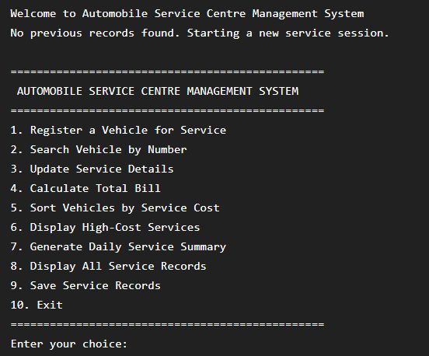
Test Case 2: Successful Registration of Normal Vehicle Service
OUTPUT:
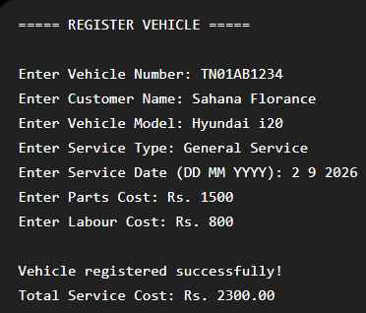

Test Case 3: Registration of High-Cost Engine Repair Service
OUTPUT:
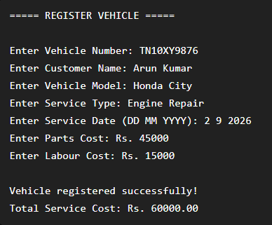
Test Case 4: Searching and Displaying an Existing Vehicle Record
OUTPUT:
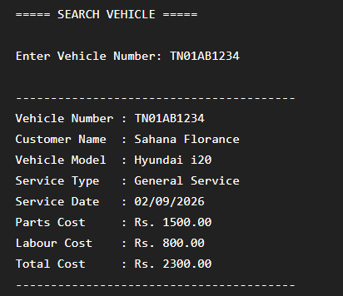
Test Case 5: Updating Service Details Using Pointer to Structure
OUTPUT:
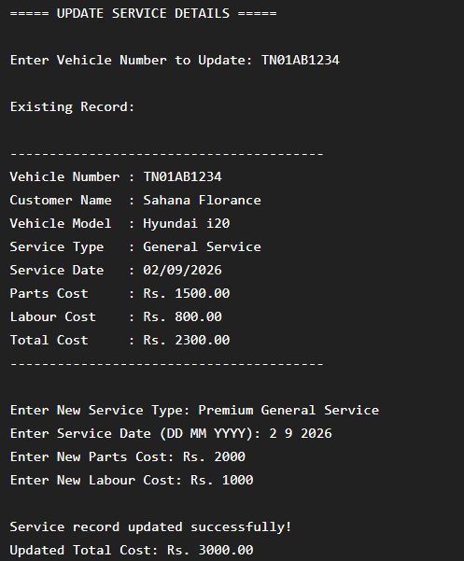
Test Case 6: Vehicles Sorted from Highest to Lowest Service Cost
OUTPUT:
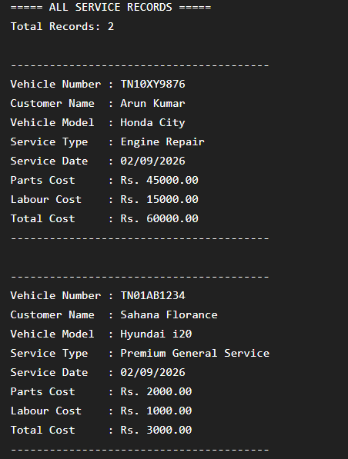
Test Case 7: Displaying Vehicles Above the Specified Service Cost
OUTPUT:
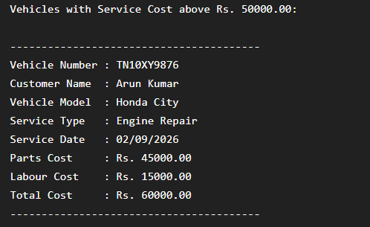
Test Case 8: Daily Service Summary and Total Revenue Calculation
OUTPUT:
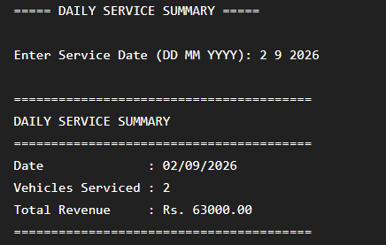
Test Case 9: Loading Previous Service Records When the Program Restarts
OUTPUT:
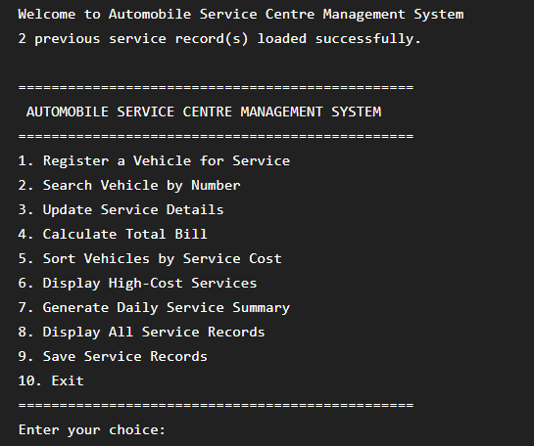
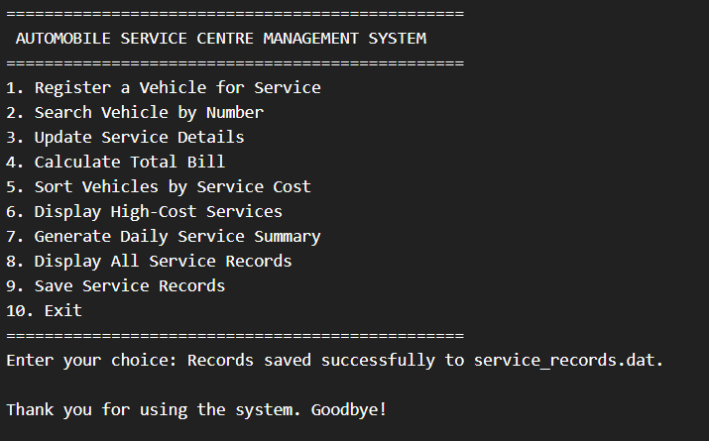
10. Analysis and Discussion
The Automobile Service Centre Management System was developed to demonstrate the practical application of fundamental C programming concepts in a real-world management scenario. The program replaces a manual service register with a structured digital system capable of storing vehicle information, calculating service costs, searching records, updating information, sorting vehicles, generating daily summaries, and permanently storing records in a file. The overall implementation was analysed based on the selection of data structures, use of pointers, searching and sorting algorithms, file-handling strategy, validation mechanisms, runtime safety, and suitability for the expected number of service records.
Structures were selected as the primary method for representing service records because every vehicle contains multiple related pieces of information with different data types. A vehicle service record includes vehicle number, customer name, vehicle model, service type, service date, parts cost, labour cost, and total service cost. Storing these values using separate variables would make the program difficult to manage, especially when multiple vehicles are registered. By grouping all related information into one structure, each vehicle can be represented as one complete service record. An array of structures allows the program to maintain multiple records efficiently and makes searching, sorting, displaying, and updating operations easier to implement.The service date was handled using separate day, month, and year values rather than storing the entire date as a simple string. This approach provides better validation and comparison capabilities. The program can determine whether two records belong to the same day and can generate daily summaries accurately. It also makes it possible to check leap years and reject impossible dates. Although storing a date as a string would be simpler, the separate representation provides better control and demonstrates a more structured programming approach.Pointers to structures were used for important operations such as calculating the total service cost and updating service details. Passing the address of a structure to a function allows the function to directly access and modify the original record. This avoids creating unnecessary copies of large structures and improves memory efficiency. The arrow operator is used to access structure members through a pointer. For example, the total service cost can be calculated directly using the parts cost and labour cost stored in the original structure. Pointer usage is particularly useful in this application because updates should immediately affect the actual service record stored in the array.
The searching requirement was implemented using Linear Search. This algorithm checks each record one by one until the required vehicle number is found. Linear Search has a best-case time complexity of O(1) when the record is found at the beginning and a worst-case complexity of O(n) when the record is at the end or does not exist. For a small service centre with a limited number of records, this approach is suitable because it is simple to implement and does not require the records to be sorted. However, if the system were expanded to manage thousands of vehicles, Linear Search would become slower. In that situation, a database index, hash table, or Binary Search on sorted data would provide better performance.For sorting vehicles according to service cost, a simple sorting algorithm such as Insertion Sort can be selected. The algorithm is suitable for small datasets and is easy to understand, implement, test, and explain during an academic evaluation. Insertion Sort has a best-case time complexity of O(n) when records are already nearly sorted and an average and worst-case complexity of O(n²). The trade-off is therefore between simplicity and execution efficiency. For a maximum capacity of approximately 100 records, the difference in execution time is not significant, and implementation simplicity is beneficial. However, if the service centre handled several thousand records, an O(n²) algorithm would become inefficient. Quick Sort or Merge Sort would be more suitable for large datasets because they provide significantly better average performance. Therefore, the selected algorithm is appropriate for the scale of the current project but may need to be changed for a large commercial application.
File handling was included to provide data persistence. Without file storage, all vehicle records would be lost when the application terminates. The system stores service records in a binary file and loads them automatically when the program starts. The record count can be stored along with the service structures so that the program knows how many records should be loaded. Binary file handling using functions such as fwrite() and fread() is suitable for this project because structures can be stored and retrieved efficiently. The major advantage of this approach is simplicity and speed. However, binary files are not easily readable or editable manually. For a larger application, a database system would provide improved scalability, security, and multi-user access.Data validation was considered an important part of the design. Duplicate vehicle numbers are rejected to ensure that each service record remains unique. Negative costs are prevented to avoid incorrect billing. Service dates are validated to ensure that daily reports are accurate. Maximum array capacity is checked before inserting new records to prevent array overflow. File pointers are checked before reading and writing to prevent operations on NULL pointers. The program also handles vehicle-not-found situations safely by verifying the search result before accessing the array. These mechanisms demonstrate defensive programming, where the software is designed with the assumption that users may enter incorrect data and external resources such as files may not always behave as expected.
A potential runtime error in the application involves array access. If the maximum number of records is exceeded and the program continues adding new vehicles, it may attempt to write outside the allocated array boundary. This could cause memory corruption or unpredictable program behaviour. The redesigned approach prevents this error by checking whether the current record count is equal to the maximum capacity before registration. Another potential runtime error involves file handling. If the program attempts to read from a file that could not be opened successfully, the file pointer may be NULL. Performing fread() using a NULL pointer may result in a crash. Therefore, the program checks the result of fopen() before performing any reading or writing operations and safely handles the situation when the file is missing or unavailable.The overall testing process demonstrated that the system performs correctly under normal, high-cost, and invalid input conditions. Normal service records were registered successfully and the total service cost was calculated correctly. High-cost services were handled without calculation errors. Invalid costs, duplicate vehicle numbers, incorrect dates, and invalid menu inputs were rejected without terminating the application. Searching, updating, sorting, high-cost filtering, daily summary generation, file saving, and file loading also produced the expected results.
The major strength of the system is that it combines several important C programming concepts into one practical application. It demonstrates the use of structures, arrays, pointers, functions, searching, sorting, file handling, input validation, and error handling. The menu-driven design makes the program easy to operate and understand. The modular function-based approach also improves readability and allows individual features to be tested separately.However, the system has certain limitations. The use of a fixed-size array limits the number of records that can be stored during execution. The application is also designed for a single user and does not include authentication or access control. Features such as GST calculation, discounts, customer contact information, mechanic assignment, spare parts inventory, invoice generation, service reminders, and online booking are not included in the current version. These features can be considered as future enhancements.
Overall, the analysis shows that the chosen design is suitable for a small to medium academic implementation. The algorithms and data structures provide a balance between simplicity, readability, and functionality. The project successfully demonstrates how a traditional manual record-management process can be converted into a computerized application using C programming concepts. It also highlights that reliable software development requires not only correct functionality but also proper validation, error handling, and safe management of system resources.
11.Conclusion
The Automobile Service Centre Management System was successfully designed as a C-based application to replace the traditional manual service-register process with a structured computerized solution. The main objective of the project was to manage vehicle service records efficiently while applying important C programming concepts such as structures, pointers, functions, arrays, searching, sorting, file handling, input validation, and error handling.The system stores complete information related to each vehicle, including the vehicle number, customer name, vehicle model, service type, service date, parts cost, labour cost, and total service cost. Structures were used to organize this information into meaningful records, making it easier to manage multiple vehicles using an array of structures. The use of a separate date representation also improved the validation and comparison of service dates.Pointers to structures were effectively used in functions responsible for calculating the total service cost and updating service details. This allowed the functions to directly access and modify the original service records without unnecessary copying. The project therefore demonstrates the practical importance of pointers in improving efficiency and enabling direct data manipulation in C programs.The menu-driven interface provides the user with all the required functions, including vehicle registration, vehicle searching, service record updating, total bill calculation, sorting based on service cost, displaying high-cost services, generating daily service summaries, storing records in a file, and loading previous records when the application starts. These features make the application suitable for managing the basic operations of an automobile service centre.
Special attention was also given to validation and error handling. The program prevents duplicate vehicle numbers, rejects negative costs, validates service dates, checks maximum record capacity, handles invalid menu input, verifies file operations, and prevents invalid array access. These mechanisms improve the reliability of the system and ensure that the application continues functioning safely even when unexpected conditions occur.The selected algorithms were evaluated based on the number of records expected in the system. Linear Search and Insertion Sort provide simple and understandable solutions for a small dataset. Although these algorithms are not the most efficient for very large datasets, they are appropriate for the current project because of the limited number of records and the importance of implementation simplicity. The analysis also identified that future versions could use faster algorithms and database systems if the number of vehicles increased significantly.
The testing process confirmed that the application works successfully for normal service scenarios, high-cost services, and invalid input conditions. All major operations produced the expected results, and invalid situations were handled gracefully without causing program crashes. File handling ensured that records could be saved and retrieved even after the program was closed and restarted.In conclusion, the Automobile Service Centre Management System successfully meets the requirements specified in the assignment. The project demonstrates the ability to apply, analyse, evaluate, and create a complete software solution using C programm`ing. It provides a practical example of how programming concepts can be used to solve a real-world record-management problem. The system also provides a strong foundation for future development, where additional features such as GST calculation, invoice generation, customer contact management, employee details, spare parts inventory, authentication, database integration, and graphical user interfaces can be added to create a more advanced and commercially useful service centre management system.
12. References
- E. Balagurusamy, Programming in ANSI C, 8th Edition, McGraw Hill Education, 2019.
- Yashavant Kanetkar, Let Us C, 19th Edition, BPB Publications, 2023.
- Brian W. Kernighan and Dennis M. Ritchie, The C Programming Language, 2nd Edition, Prentice Hall, 1988.
- Herbert Schildt, C: The Complete Reference, 4th Edition, McGraw Hill Education, 2000.
- Reema Thareja, Programming in C, 2nd Edition, Oxford University Press, 2016.
- GNU Compiler Collection (GCC) Documentation, GNU Project. Available at: GCC Documentation
- C Programming Language Documentation, TutorialsPoint. Available at: TutorialsPoint C Programming
- GeeksforGeeks – C Programming Concepts, Structures, Pointers, Searching, Sorting and File Handling. Available at: GeeksforGeeks C Programming
- Microsoft Visual Studio Code Documentation for C programming environment setup and program execution. Available at: Visual Studio Code Documentation
- ISO/IEC 9899:2018 – Programming Languages – C Standard, International Organization for Standardization (ISO).

